Exit Readiness Score  (score on a scale of 1-6) | Rating | Considerations
Brand Issues |  | Does the brand add value?
Company Documentation |  | Corp. Docs, Legal, Operating agreement, Buy-sell
Compliance Issues |  | Taxes, Environmental, Regulatory, Retirement
Credibility and Justification |  | Customers, Awards, Community
Customer Contracts |  | Customers & strategic alliances, Warranties, Maint.
Employee and Management Issues |  | Reliance, Competency, Morale, P&P, Turnover
Expense Contracts |  | Suppliers, Leases, Insurance, Web, etc.
Expense Management |  | SGA, Insurance, Banking, Cash, Payroll, GM, Payroll
Financials |  | Taxes, Financial statements, Customer analysis
Immediate Value Readiness |  | How ready right now - strategic buyer?
Intellectual Property |  | Trademarks, Patents, Software, Domains
Look at Government Grants |  | R&D, Fed., State, Local
Management Systems and Forecasts |  | 12 months - 3 years, Scorecard
Marketing Documentation and Systems |  | Systematic, proof
Payment Considerations |  | Net proceeds, Terms considerations, Exit options
Personal Expectations |  | Post sale expectations & plan
Personal Knowledge |  | Understanding of how buyers place value
Product and Marketing Strategies |  | Ansoff matrix. Products and Markets Analysis
Revenue Drivers |  | S&M, Lead generation, Conversion, Conversion rate
Shareholder Goals |  | Shareholder Alignment when how who
Systems Processes and Databases |  | CRM, Accounting, customer, sales, fulfillment
Valuation Expectations |  | Valuation, transition timeframe, needs analysis
TOTAL RATING | -
MAXIMUM RATING | 132
Readiness Score (Your Total / 132 = %) | -
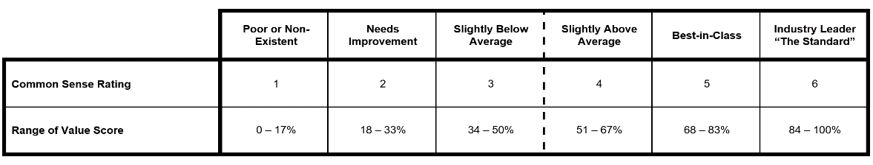
Instructions:
Step 1. Rate each category from 1-6, based on the below key:
- Bad/Nonexistent
- Needs Improvement
- Slightly Below Average
- Slightly Above Average
- Best-in-Class
- In a Class of One
Step 2. Add all ratings together and put your total in the TOTAL RATING section.
Step 3. Divide your TOTAL RATING by the MAXIMUM RATING of 132. The result will be your percentage READINESS SCORE.
Example:
TOTAL RATING = 88
MAXIMUM RATING = 132
88 / 132 = .67
READINESS SCORE: 67%
Copyright Exit Planning Instituet

